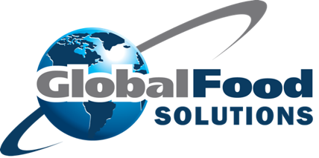
Supplier Food Safety Agreement

To Whom It May Concern:

The Food Safety Program adopted by our company requires an agreement from the supplier to meet minimum conditions.

It is important to our organization that all food and associated products, including packaging materials, are of high quality and meet appropriate standards. In accordance with the provisions of our Food Safety Program we ask you to confirm your acceptance of the following:

Certifications / Registrations:
Please supply us with a copy of the food safety audit certificate and the audit report. This measure is to verify your facility meets our food safety standard.

Product Specifications:
Please supply us with all product specifications. If the product changes in any way (formulation, allergens, process, etc.) please inform Global Food solutions immediately, so we can update our records and labels accordingly.

Package and labelling requirements:
All food products are to be delivered in food grade containers that are free from chemical or physical contaminants.

Delivery vehicles and drivers:
Your delivery drivers will be well presented and follow good personal hygiene practices. Your delivery vehicles, when delivering to us will be clean inside and outside and will not be used transport products that could adversely affect food safety. If vehicles are used for delivery of chemicals such as cleaning or sanitizing chemicals, or other substances that could adversely affect the quality of the food, then they will be separated from the food products in such a way as to prevent any contamination or tainting of the food.

We will not accept delivery of any items that are not delivered to us according to this agreement. We will not accept delivery unless an employee from our company is present and signs for the delivery.

Conditions for supply:
It is required that all foods supplied comply with the Food Standards Code at all times. Failure to do so will result in refusal of the goods.

Acceptance
If you accept these conditions, please sign and date a copy of these conditions and return it to us. If you would like clarification on any of these conditions, please contact us.

On behalf of Global Food Solutions, we appreciate your cooperation and compliance to helping our food safety system thrive.

Michael Levine
CEO
Global Food Solutions
50 C. Constance Court
Hauppauge, N.Y. 11788
Tel (877) 728-5550
Mikelevine@Globalfoodsolutions.CO

Supplier’s acceptance
Supplier:
Address:
Phone:
Goods supplied:

Name:
Signature: Date:

